See and Spell words for “Blueberries for the Queen”

GIFT

BOY

SHIP

DRAGON

BASKET

BERRIES

PRINCESS

KING

CASTLE

QUEEN

Use scra

How to play: Cut cards out. Use scrabble tiles or other letter chips to spell the word

|  |
| --- |
|  |

|  |
| --- |
|  |

|  |
| --- |
|  |

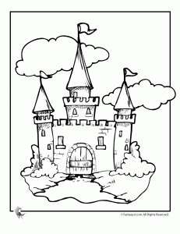 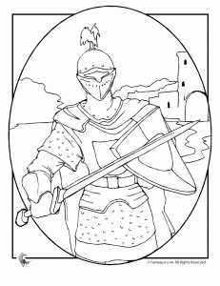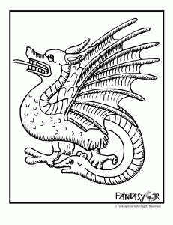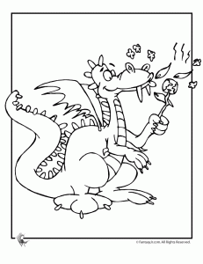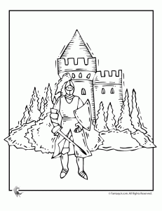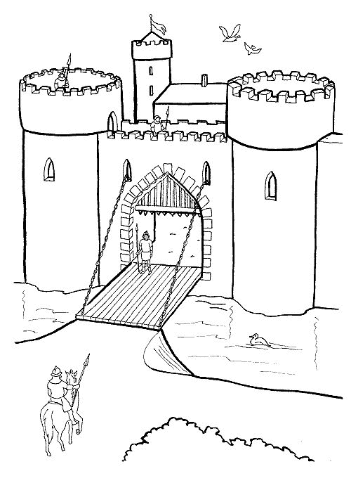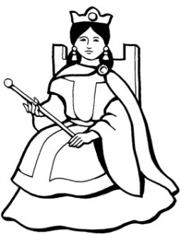 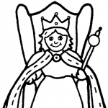 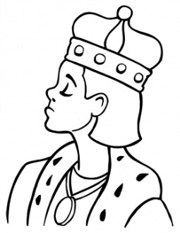 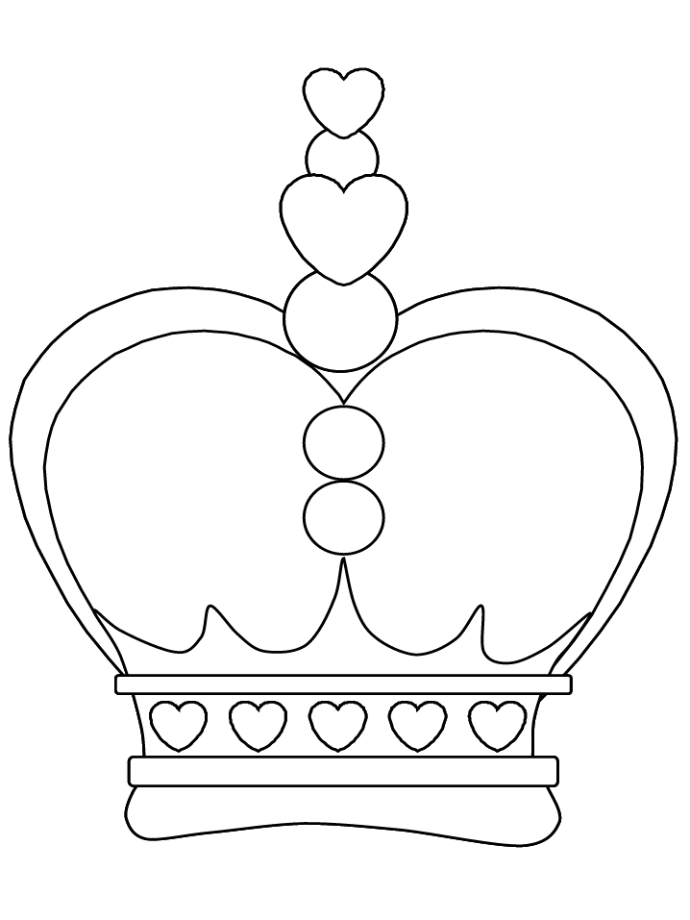

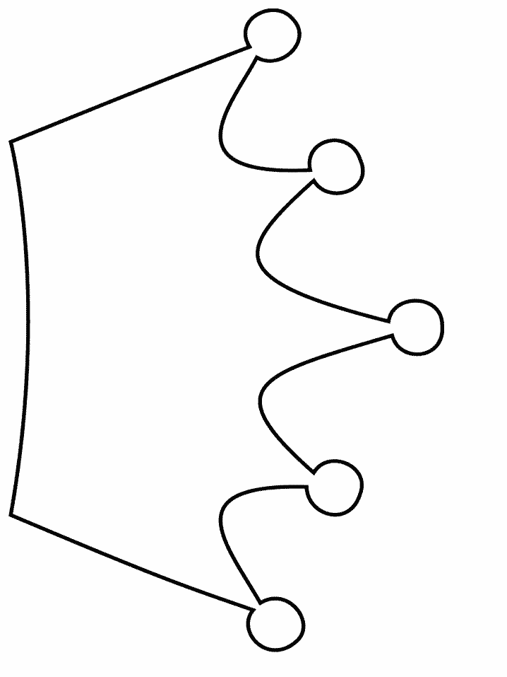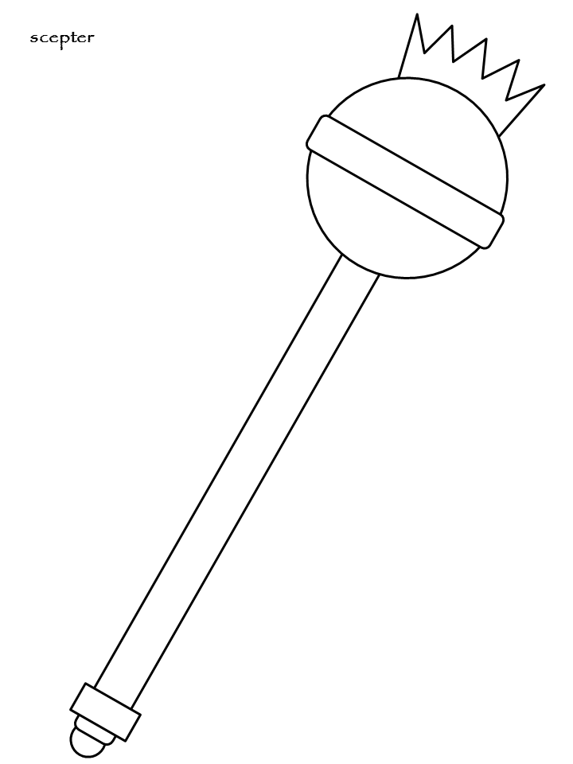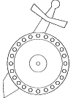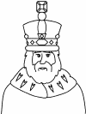 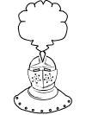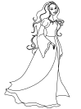 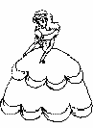 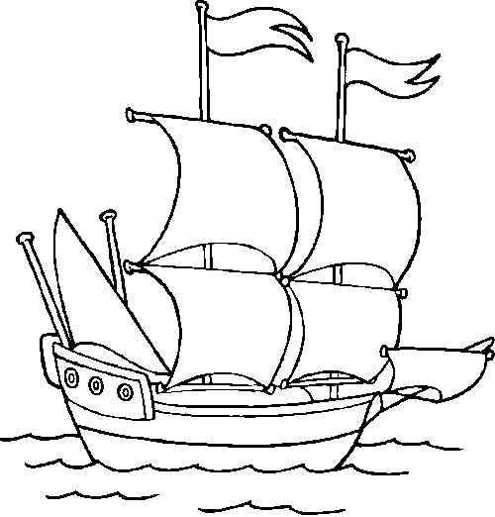 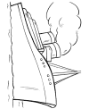 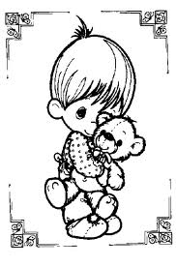 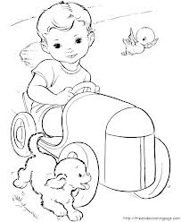 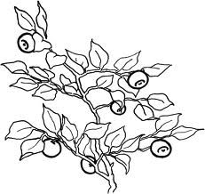

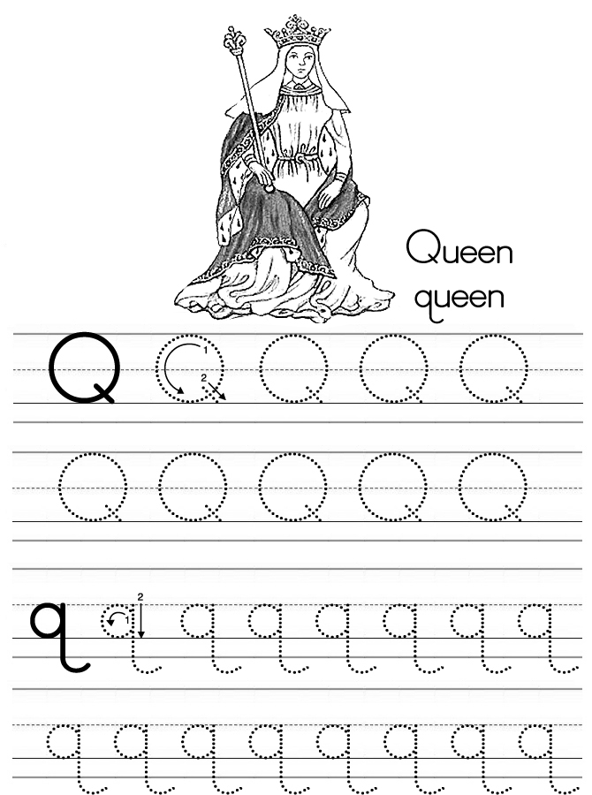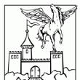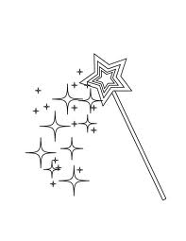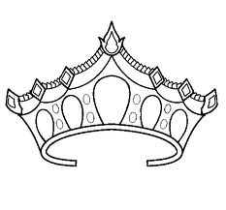http://www.fantasyjr.com/wp-content/themes/tma-2009/images/shadow.pnghttp://www.fantasyjr.com/wp-content/themes/tma-2009/images/shadow.pnghttp://www.fantasyjr.com/wp-content/themes/tma-2009/images/shadow.pnghttp://www.fantasyjr.com/wp-content/themes/tma-2009/images/shadow.png

Easy Reader-early sight words. (This/is/a). Staple along left edge.

This is a ship.

This is a castle.

This is a crown.

This is a boy.

This is a queen.

BLUEBERRIES

FOR THE

QUEEN

