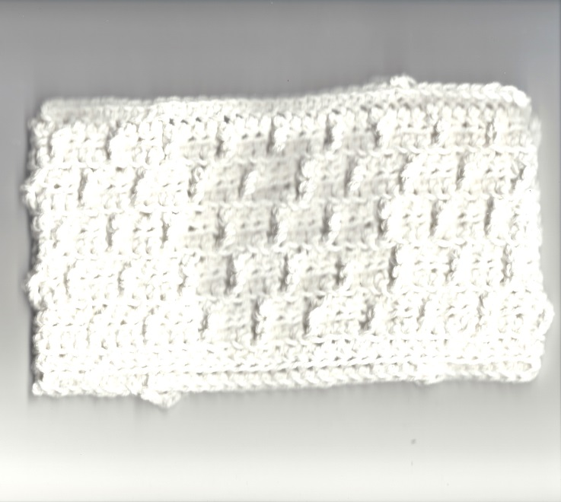

CROCHET SWIFFER CLOTH
Designed by Dari Thacker
©2013
You may sell items made from this pattern, but you may not sell my pattern. I only ask you to give me credit for the design. Thanks!

Materials:
1 skein (2 oz./ 56.7 g) 100% cotton worsted weight yarn
H/ 5 mm Crochet Hook, or to obtain gauge

Stitches:
CH- chain
SC- single crochet
HDC- half double crochet
FPTC- front post treble crochet
SL- slip stitch

BLO- back loop only
FLO- front loop only

Gauge: 4 stitches= 1 inch
Instructions:

Chain 56 (or until 14”). Chain 1 more.
Row 1: skip 2 chains, HDC in BLO each of stitches across. Chain 1. Turn.
Row 2: HDC in BLO of this stitch and in every stitch across. Chain 1. Turn.
Row 3: HDC in FLO of this stitch and in the next 7 stitches, *FPTC in next stitch, HDC in FLO of next 3 stitches, repeat from * until 8 stitches are left. HDC in FLO of these remaining stitches. Ch 1. Turn.
Row 4: Repeat row 2.
Row 5: HDC in FLO of this stitch and in the next 9 stitches, *FPTC in next stitch, HDC in FLO of next 3 stitches, repeat from * until 8 stitches are left. HDC in FLO of these remaining stitches.
Row 6: Repeat row 2.
Row 7: Repeat row 3.
Row 8: Repeat row 2.
Row 9: Repeat row 5.
Row 10: Repeat row 2.
Row 11: Repeat row 3.
Row 12: Repeat row 2. Fasten off.
Fold over both ends 8 stitches. Use pins to hold in place if needed. Starting at far edge, SC across entire top including the main body. Fasten off at other end. Repeat for the bottom.
SL into the raw edge of the folded over flap. * CH 5, skip 2 stitches, SL into 3rd stitch from hook. Repeat from * across. Fasten off. Repeat to other side flap.
Weave in all ends.

