GINGERBREAD BABY COUNTING GAME

Hello! I am happy to share this creation with you. I created this game to help
young children learn and master one-to-one ratios and numeral recognition. This game is
pretty straight forward. The child counts the chocolate chips on the gingerbread cookie
and places it on top of the corresponding numeral cookie on the cookie sheet.

To make: I recommend printing the gingerbread men with the chocolate chips onto
a light brown cardstock. Cut them out. For the gingerbread men with the numerals on them,
you can just print them out on white paper. You will cut these out and glue them onto the
“cookie sheet” (pan page). For the cookie sheet, you will need to print 2 out on grey cardstock.
Tape these two halves together on the back so they fold together OR glue them onto a file
folder. Store the pieces in a baggy inside the game.

Thanks! As always, you are welcome to use this game for your personal or educational use,
but you may not sell it. Hope you enjoy. –Dari daris-corner.blogspot.com,
daris-corner.weebly.com

© Dari Thacker 2014
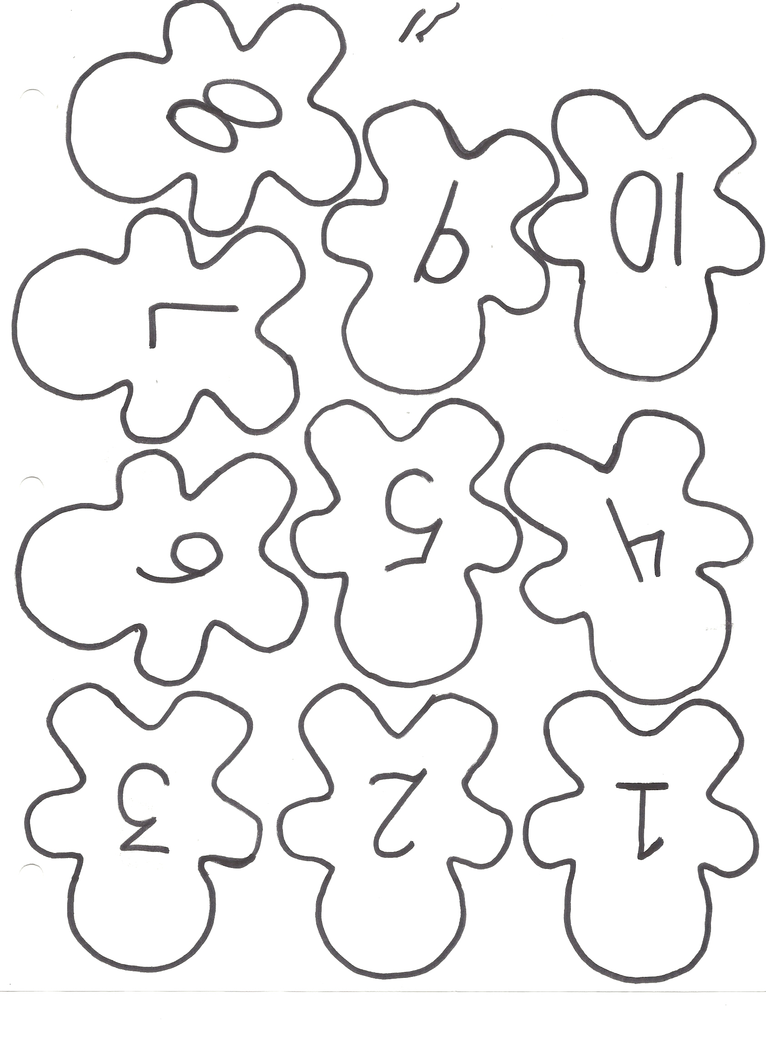
© Dari Thacker 2014
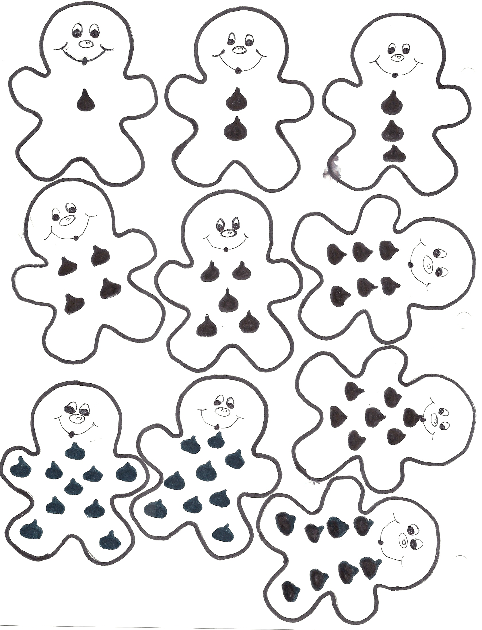
© Dari Thacker 2014
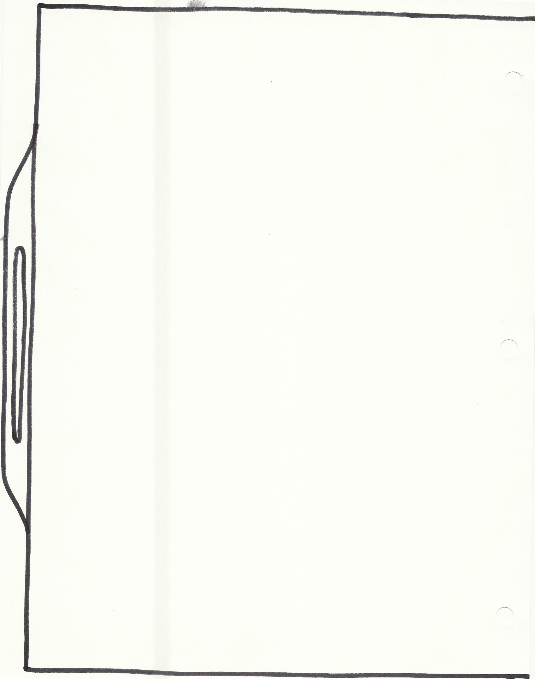
© Dari Thacker 2014

