TROPICAL FLOWER HEADBAND

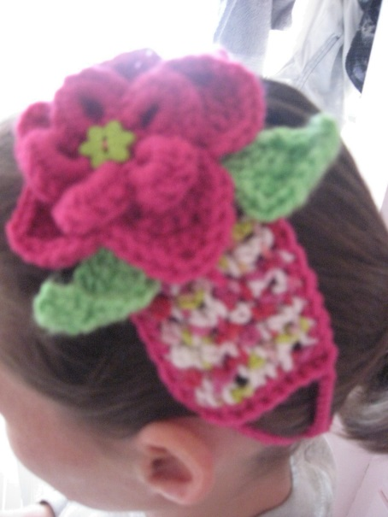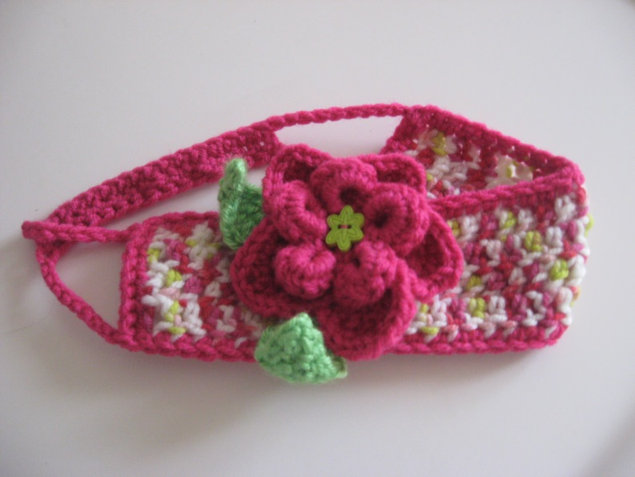

Designed and Created by Dari Thacker
© Dari Thacker 2013.
All rights reserved. You may sell finished products created from my pattern, but you must credit me for the design. You may not sell my pattern. Please link the source to daris-corner.weebly.com or daris-corner.blogspot.com. Thank you! Hope you enjoy!

Materials needed:
Crochet Hook size H
Small amounts of 3 different worsted weight yarns (less than 1/3 skein of each).
1 button
Sewing needle and thread

Stitches used: (US Terms)
SC= single crochet
HDC= half double crochet
DC= Double crochet
SL= slip stitch
CH= chain

HEADBAND BASE

CH 35.
ROW 1: Skip first 3 chains. DC in each chain across. CH 3 and turn (counts as first DC of next row).
ROW 2-4: In next stitch, DC. DC in remaining stitches. CH 3 and turn. On ROW 4, omit the CH 3 at end.
Fasten off. Weave in ends.

BORDER EDGE (With contrasting color):
SL in the top of any outside edge stitch. CH 2 (counts as SC). SC in each stitch around headband base. In corner stitches, SC 3. When you reach the beginning, join to top of beginning SC with a SL.

HEADBAND STRAP (with same contrasting color):

SL into the middle of 3 SC at corner. CH 35 (Adult X-small/ 40 small/ 45/regular). SL into middle of 3 SC at matching corner on other end (fold headband base in half lengthwise and match corners). SL into each SC on short end of Headband base edge. When you reach the middle of 3 SC at corner, SL into it, then CH 10. On other strap, count 10 from edge. Mark this stitch. DC in next 15 stitches. CH 10 more. Join to other corner with a SL. *Note: If you are doing an adult small or regular, simply DC more stitches leaving 10 CH on either end.

FLOWER

(same contrasting color as edge and strap)

Inner flower:
CH 5. SL in first. CH 5, SL in same base chain. *SL in next chain stitch, CH 5, SL in base, Repeat from *.
SL in space of first loop of 5, *CH 1, 7 HDC in space. SL in space of next loop of 5, repeat from *.
At end, SL in base stitch of first petal. Fasten off and weave in ends.

Outer flower:
Leave a long tail. You will use this tail to attach the flower to the headband base.
CH 5, SL in first. CH 2 (counts as SC), SC in same stitch, 2 SC in each remaining chain. SL in top of beginning CH 2 (10 SC).
*CH 3, SL in next stitch, SL in next stitch, repeat from * around (5 chain loops).
*SL in SL stitch between the 2 chain loops you’re at. CH 2, 5 DC in chain loop space, repeat from * around. SL into beginning SL.
*SL into first CH stitch, 2 SC in next stitch, 2 HDC in next; 1 DC, CH 1, 1 DC in next stitch; 2 HDC in next, 2 SC in next, SL in SL stitch of previous row. Repeat from *. Fasten off.

LEAF
(Use other contrasting color)

Leave a long tail here. This will allow you to attach the leaf base to the flower. CH 10, SC in 2nd & 3rd Chains, HDC in next, DC in 5th; DC, CH 1, DC in 6th; HDC in 7th, SC in 8th & 9th, 3 SC in 10th. You should find yourself on the other side of the leaf now. You will repeat the same pattern in reverse- SC in next 2 stitches, HDC in next; DC, CH 1, DC in next; DC in next stitch, HDC in next, SC in next 2 stitches, SL into point of leaf. Fasten off and weave in this end. Make 2 leaves.

ASSEMBLING THE FLOWER & LEAVES

Lay the inner flower on top of the bottom flower with the WRONG side facing up! I positioned mine so that the arches of the inner flower lined up with the valleys of the bottom flower. Center your button in the middle. Using a sewing needle and thread, sew the button through all layers of the flower several times. Tie off on back side.

Place the leaves under the flower where you would like them (I placed the center of each in a valley of the bottom flower). Using the long tail, whip stitch to the underneath of the bottom flower. Be careful to not come up through the top. You don’t want green specks showing on top. Fasten off and weave in ends.

Position your flower onto the headband as desired. Using the long tail from the bottom flower, make running stitches through headband base and bottom flower layer to secure the flower to the base. Fasten off and weave in end.

