BUNNY MONEY GAME
Based on the story written by Rosemary Wells
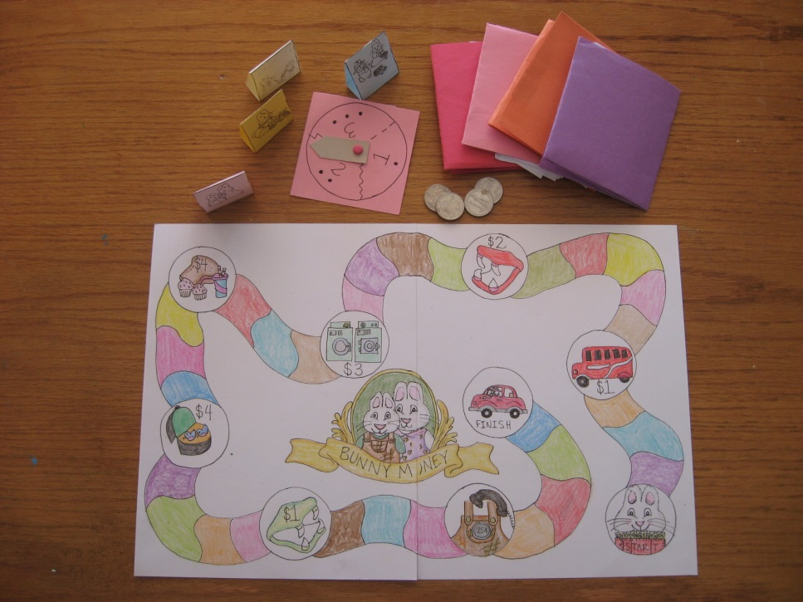
I am so excited to put this together. I just love Rosemary Wells’ books. This year I have designed, gathered and created the preschool curriculum we have used. It has been fun. During the week we learned about the letter B, I centered all the curriculum around this book, Bunny Money. This game was such a hit that my four year old wanted to play it multiple times every day!
This game is a perfect “first” board game, because it only uses numbers 1-3; thus allowing young children to more easily master and be able to count the one to one ratios required to move their pieces. The board follows the sequence of the story. All players will end up spending their money just as Ruby and Max do in the story. This reinforces story comprehension and story sequencing. For our preschool, we helped each student make her own game so she could take it home and play it with her family.
Credits: I drew the game board and spinner by hand, but I copied and pasted different online coloring sheets for the playing pieces and money from various sources. I also used Rosemary Wells’ book for inspiration and cohesiveness. Many thanks to these!
You are free to use this game for personal or educational use. I hope you enjoy it as much as we have! –Dari Thacker
TO MAKE: Print the board game halves on cardstock. Color and tape them together in the back. Cut out the player pieces (note: there are enough on each sheet for two games). Fold the pieces along the lines and glue so they are standing triangles. Print out the spinner on cardstock (the page provided will make 6). Using the scraps along the edges of the paper or a contrasting color, cut a ½ wide strip of paper, lay it in the center of the spinner and then cut the length of the strip so that it is almost touching the outer spinner edge. Shape one end of this strip so it is pointed. Punch a hole in the other end and one in the center of the spinner. Insert a brad into the arrow and then the spinner and separate the two brad pieces on the back side. I have found that if you press them down loosely (so they don’t hug the paper tight), and then gently bend the spinner towards the brad it helps the spinner “spin” better. For the money: You can either print off real bunny money from Rosemary Wells’ website or you can print off the ones I made from online coloring sources. Whichever way you decide you will need 10 ones and 1 five for EACH player. So, for four players (the number I designed the game for), you will need 40 ones and 4 fives. For the wallets, which my four year old said were a necessity, you will need a piece of construction paper or cardstock for each. You can find the tutorial for this on my blog: darid-corner.blogspot.com. The basic idea is that you fold over one of the long edges and crease an inch below the top. This creates the bottom. Glue the two sides and then fold the wallet in thirds. You need to gather a quarter for each player as well.
TO PLAY: Give each player a playing piece and a wallet filled with 10 ones, 1 five, and a quarter. Place all playing pieces on START. Decide who goes first. She spins and moves accordingly. If she lands on OR passes a circle with a picture and a price, she pays that correlating amount to the designated banker (I like to keep all players’ money separate so it is easier to put them back in the individual wallets at the end for the next game). Play continues clockwise. As mentioned before, each player will run out of money just like the characters in the story do. In order to reach the finish, you have to spin the exact amount. Also, more than one player can be on a designated spot. Just make room. At our house, when you reach the PHONE circle, you have to pretend to call Grandma and ask her to come and get you.
That’s it! Hope you enjoy!

